========================
server.py
========================

import socket
import threading
import datetime

client_counter = 0

def handle_client(conn, addr, client_name):
print(f"{client_name} connected from {addr[0]}:{addr[1]}")

while True:
data = conn.recv(1024).decode().strip()

if not data:
break

if data == "QUIT":
print(f"{client_name} disconnected.")
conn.close()
return

if ":" not in data and data not in ["TIME", "DATE"]:
response = f"ERROR: Unknown command from {client_name}."
conn.send(response.encode())
print(f"{client_name} sent: {data} → {response}")
continue

# BONUS: TIME & DATE
if data == "TIME":
result = datetime.datetime.now().strftime("%H:%M:%S")
conn.send(result.encode())
print(f"{client_name} sent: TIME → {result}")
continue

if data == "DATE":
result = datetime.datetime.now().strftime("%Y-%m-%d")
conn.send(result.encode())
print(f"{client_name} sent: DATE → {result}")
continue

command, message = data.split(":", 1)
command = command.strip()
message = message.strip()

# Execute commands
if command == "UPPER":
result = message.upper()
elif command == "LOWER":
result = message.lower()
elif command == "REVERSE":
result = message[::-1]
elif command == "COUNT":
result = str(len(message))
# BONUS: VOWELS
elif command == "VOWELS":
vowels = "aeiouAEIOU"
count = sum(1 for ch in message if ch in vowels)
result = str(count)
else:
result = f"ERROR: Unknown command from {client_name}."

conn.send(result.encode())
print(f"{client_name} sent: {data} → {result}")

def main():
global client_counter

server = socket.socket(socket.AF_INET, socket.SOCK_STREAM)
server.bind(("0.0.0.0", 2210))
server.listen()

print("Server is running on port 2210")

while True:
conn, addr = server.accept()

client_counter += 1
client_name = f"Client{client_counter}"

thread = threading.Thread(target=handle_client, args=(conn, addr, client_name))
thread.start()

main()

Run in Terminal:

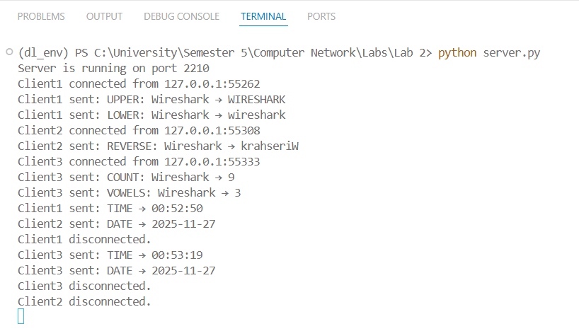

========================
client.py
========================

import socket

client = socket.socket(socket.AF_INET, socket.SOCK_STREAM)
client.connect(("127.0.0.1", 2210))

print("Connected to server.")

while True:
msg = input("> ")

client.send(msg.encode())

if msg == "QUIT":
print("Connection closed.")
client.close()
break

data = client.recv(1024).decode()
print("Response from server:", data)

Run in Terminal:
Client 1:
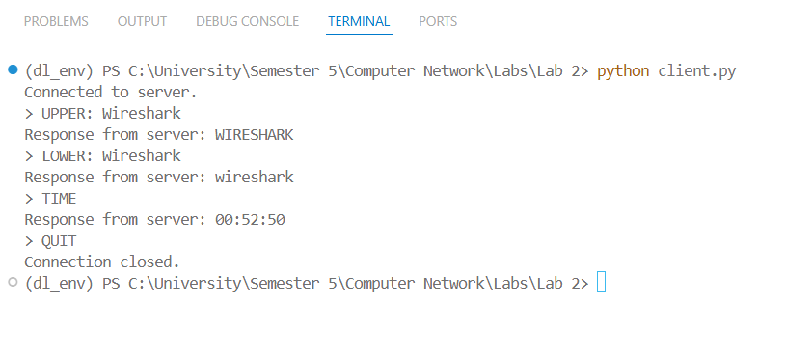
Client 2:
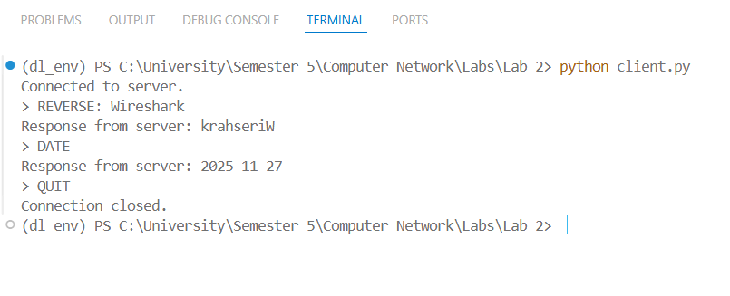
Client 3:
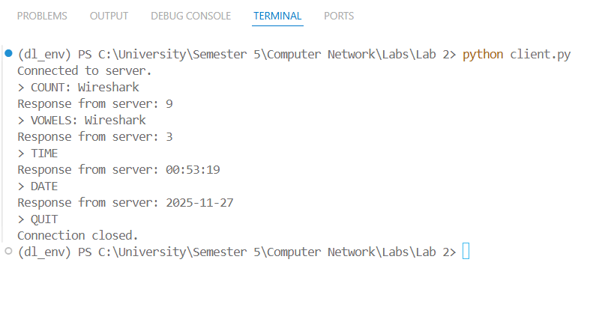
Wireshark:

Using filter tcp.port == 2210 → Shows packets that use TCP port 2210 only

